Format Hampton Hills Newsletter
Apply formatting to make a single page newsletter from the provided information.
Here is an example. Follow this example to create your own using similar or added features.
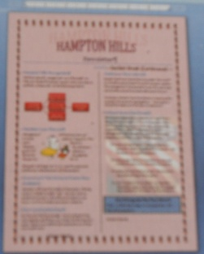

HAMPTON HILLS

Newsletter
  - June

Hampton Hills Reorganizes
We have recently reorganized our office staff. To help you locate the correct person when you have a problem, please refer to the following chart.

- Jose Franco. Office Manager
- Bob and Sue Ming, Superintendents
- Patsy O’Malley, Personnel Director
- Don Peters, Activities Director

Hawaiian Luau Planned
Management will host our annual summer party on August 1. This year’s theme is Hawaiian. You and your guest will receive a flower lei donated by Flowers for You.
The party will begin at 7 p.m. near the pool and clubhouse. Refreshments will be served.

Amusement Park Discount Tickets Now Available
Hampton Hills and the Parks of Peoria are offering discount tickets to Safari Park. You can pick up tickets and a map in the office during business hours. Limit five tickets per person please.

New Laundry Machines
Our laundry facility manager has purchased three new washers and three new dryers for the laundry room. There is no additional expense to use these new machines.

Clubhouse Reservations
Several local businesses have requested the use of our clubhouse and pool for small company parties. The management has decided to rent the pool area and clubhouse to businesses after pool hours.
As always, tenants have first choice in reserving the property for personal get-togethers. Reservations should be made up to 30 days in advance.

Independence Day Parade
The Peoria Independence parade will pass down Dover Avenue directly in front of Hampton Hills. We’ll have the best seats in the city. Because the route passes so close to Hampton property, management asks you to observe the following precautions so that no one will be injured.
- Keep children and animals on Hampton property. Make sure they don’t wander into the street during the parade.
- Remember that no fireworks are allowed inside the city or on Hampton property.
- Keep your animal on a leash. This is a city law that will keep them safe.
- Don’t park on Dover Street on Saturday. The street needs to be clear for the parade. Cars parked on the street will be towed.

Don’t Forget to Pay Your Rent!
There is a $25 late charge for rent paid after the fifth of the month.

